EXPERIMENT 3
ENERGY AND POWER ANALYSIS OF SIGNALS DATE: 14.06.26
OBJECTIVE:
(i) To calculate the energy and average power of given continuous-time and discrete time signals and classify them as energy signals, power signals, or neither based on their energy and power
characteristics.
PROCEDURE
- Define the time vector and generate the selected signals.
- Compute the squared magnitude of each signal.
- Numerically integrate over a sufficiently large interval for energy.
- Compute average power over an interval containing several periods for the periodic signal.
- Compare numerical results with analytical expectations.
- Classify the signals and record observations.
CODE
clc; clear; close all; dt = 0.001;
t = 0:dt:5;
xE = exp(-t);
xP = sin(2*pi*5*t);
E_num = trapz(t,abs(xE).^2); T0 = 1/5;
idx = t <= 2;
P_num = (1/(t(find(idx,1,'last'))-t(1))) *trapz(t(idx),abs(xP(idx)).^2); figure;

subplot(2,1,1); plot(t,xE); grid on;
title('Energy Signal e^{-t}u(t)');
xlabel('Time (s)'); ylabel('Amplitude'); subplot(2,1,2);
plot(t,xP); grid on;
title('Power Signal sin(2pi5t)'); xlabel('Time (s)'); ylabel('Amplitude'); fprintf('Numerical energy = %g\n',E_num);
fprintf('Numerical average power = %g\n',P_num);
OUTPUT
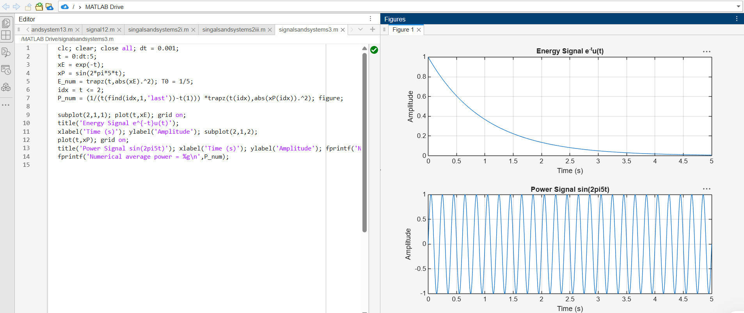

RESULT
Numerical energy = 0.499977 Numerical average power = 0.5
Energy and average power were calculated successfully, and the given signals were classified as energy and power signals based on their energy and power characteristics.

LABORATORY PERFORMANCE ASSESSMENT RUBRICS:

Objective | Assessment Criterion | Excellent – 4 | Good – 3 | Satisfactory – 2 | Needs Improve ment – 1 | Weight age | Marks given | Marks obtai ned
Calculate the energy and average power of given signals | Energy & Power Calculation | Correctly calculates signal energy and average power using appropriate mathematical expressions and MATLAB  implementation  independently. | Performs calculation s correctly with minor numerical or coding errors. | Performs basic calculations but requires guidance or has noticeable errors. | Unable to correctly calculate energy or power. | 25 | 2.5
Distinguish energy signals and power signals | Signal Classificatio n | Correctly classifies signals as energy or power signals based on calculated values and theoretical conditions. | Correctly classifies signals with minor errors or limited justificatio  n. | Performs basic classification but requires assistance or provides incomplete  justification. | Unable to classify  the signal correctly. | 25 | 2.5
Implement numerical energy/power computation using MATLAB | MATLAB  Implementat ion &  Numerical Analysis | Develops accurate  MATLAB code,  obtains reliable numerical values and appropriately selects the integration/summation interval. | Code and numerical results are mostly correct with minor errors. | Implements the basic computation with assistance or noticeable numerical errors. | Unable to impleme nt the required MATLA B  computat  ion. | 25 | 2.5
Compare analytical and simulated results | Theoretical Validation & Comparison | Accurately compares theoretical and  simulated values, calculates deviation where applicable and explains discrepancies  clearly. | Provides correct compariso n with minor deviations  and | Provides basic comparison but validation or interpretatio  n is limited. | Unable to compare or validate the  results. | 25 | 2.5

